

Asset Practice Questions: Science

**1. Which of the following covers most of the Earth's surface?**

**A.** sand **B.** water **C.** cities

**D.** mountains

**2. The upper part of an umbrella marked here, is made of a special type of cloth.**

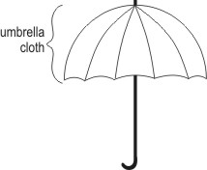

**Which of the following BEST describes an umbrella cloth? A.** It must be very heavy.

**B.** It must not be white in colour.

**C.** It must be able to sink in water.

**D.** It must not allow liquids to pass through.

**3. What is the common use of the vehicle shown below?**

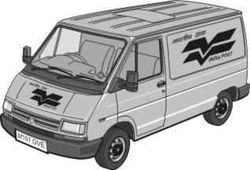

**A.** To catch dogs in the streets

**B.** To take sick people to hospital

**C.** To carry letters and parcels

**D.** To catch bad people and put them in jail

**4. Some animals give birth to young ones and DO NOT lay eggs. Such animals are called 'mammals'.**

**Which of the following is a 'mammal'?**

**A.** Rabbit

**B.** Lizard

**C.** Butterfly

**D.** sparrow

**5. The symbol given below is printed on a packet of wafers.**

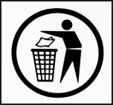

**What message does it give?**

**A.** Do not make your surroundings dirty.

**B.** Store in a cool, dry place.

**C.** Eat healthy, stay healthy.

**D.** Do not crush the packet.

**6. Rahim, Sharda, James and Shelly were discussing whether cake and juice are food items. Here is what they said:**

**Rahim: ''Only cake is a food item as it is solid.''**

**Sharda: ''Only juice is a food item because it is healthy.''**

**James: ''Both cake and juice are food items because they give us energy.''**

**Shelley: ''Cake is not a food item because it is not eaten at meals.'' Who is correct? A.** Rahim

**B.** Sharda **C.** James

**D.** Shelley

**7. “I am a part of a living thing.”**

**“I can be of different colours and shapes.”**

**“I am eaten by other living things”.**

**Who am I?**

**A.** leaf **B.** beak **C.** nails **D.** chalk

**8. Which of these can you easily break with your hands?**

**A.** A tennis ball

**B.** A matchstick

**C.** A metal spoon **D.** A plastic straw

**9. Which of these animals lay eggs?**

**A.** Dogs

**B.** Lizards

**C.** Humans **D.** Monkeys

**10. A bucket can hold about 20 litres of water. A jug can hold LESS than 1 litre of water. How many jugs of water do you need to fill this bucket?**

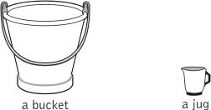

**A.** Less than 10 jugs

**B.** 10 jugs

**C.** 20 jugs

**D.** More than 20 jugs

**11. Gold is expensive and so it should be measured very carefully. A little more or a little less weight can change its price. What kind of machine should be used to weigh gold?**

**A.** Weighing machines that weigh human beings.

**B.** Weighing machines that can measure very large weights.

**C.** Weighing machines that can measure very small weights.

**D.** Weighing machines that are commonly used in provision stores.

**12. Aarti urgently wants to contact her friend who lives in another city. Which is the quickest way for her to do it?**

**A.** By telephone

**B.** By parcel

**C.** By postcard

**D.** By television